 



Database Programming with SQL

* 1. : Using GROUP BY and HAVING Clauses Practice Activities

# Objectives

* + - Construct and execute a SQL query using GROUP BY
    - Construct and execute a SQL query using GROUP BY … HAVING
    - Construct and execute a GROUP BY on more than one column
    - Nest group functions

# Vocabulary

Identify the vocabulary word for each definition below.

|  |  |
| --- | --- |
| **HAVING** | Used to specify which groups are to be displayed; restricts groups that do not meet group criteria |
| **GROUP BY** | Divides the rows in a table into groups |

# Try It / Solve It

1. In the SQL query shown below, which of the following is true about this query?

a. Kimberly Grant would not appear in the results set. ПРАВДА

b. The GROUP BY clause has an error because the manager_id is not listed in the SELECT clause. ЛОЖЬ столбец не должен выводиться, чтобы по нему группировать

c. Only salaries greater than 16001 will be in the result set. ЛОЖЬ не обязатель, если входит в группу то будет и меньше

d. Names beginning with Ki will appear after names beginning with Ko. ЛОЖЬ сортировка по фамилии

e. Last names such as King and Kochhar will be returned even if they don’t have salaries > 16000. ЛОЖЬ только если в группе есть больше 16000

SELECT last_name, MAX(salary) FROM employees

WHERE last_name LIKE 'K%' GROUP BY manager_id, last_name HAVING MAX(salary) >16000

ORDER BY last_name DESC ;

1. Each of the following SQL queries has an error. Find the error and correct it. Use Oracle Application Express to verify that your corrections produce the desired results.
   1. SELECT manager_id FROM employees

WHERE AVG(salary) <16000

GROUP BY manager_id;

SELECT manager_id,AVG(salary)

FROM employees

GROUP BY manager_id

HAVING AVG(salary) <16000;

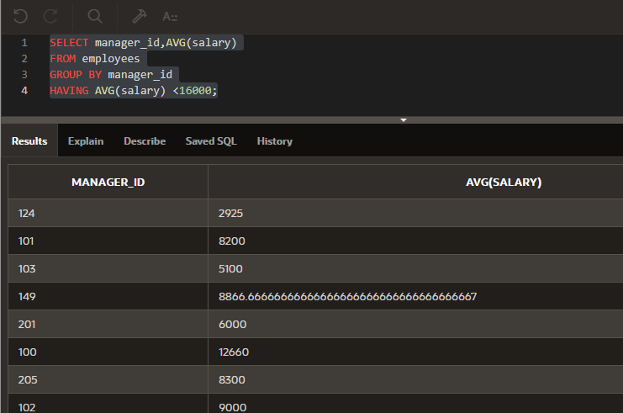

* 1. SELECT cd_number, COUNT(title) FROM d_cds

WHERE cd_number < 93;

SELECT COUNT(*)

FROM d_cds

WHERE cd_number < 93;

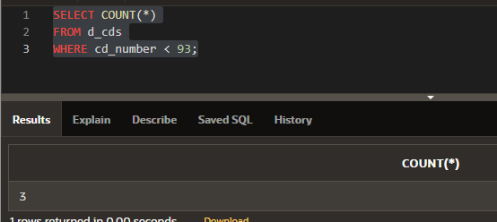

* 1. SELECT ID, MAX(ID), artist AS Artist FROM d_songs

WHERE duration IN('3 min', '6 min', '10 min') HAVING ID < 50

GROUP by ID;

SELECT type_code, MAX(TO_NUMBER(REPLACE(duration,' min',''))) || ' min' as "max duration"

FROM d_songs

WHERE duration IN('3 min', '6 min', '10 min') AND id < 50

GROUP BY type_code;

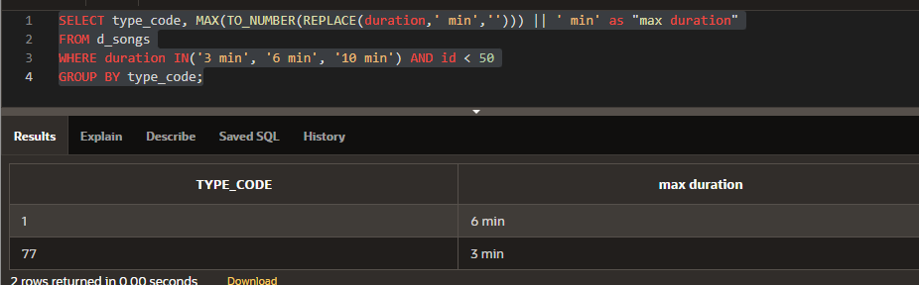

* 1. SELECT loc_type, rental_fee AS Fee FROM d_venues

WHERE id <100 GROUP BY "Fee" ORDER BY 2;

SELECT loc_type, AVG(

CASE

WHEN INSTR(rental_fee, '/hour') != 0 THEN TO_NUMBER(REPLACE(rental_fee,'/hour',''))*5

WHEN INSTR(rental_fee, '/flat fee') != 0 THEN TO_NUMBER(REPLACE(rental_fee,'/flat fee',''))

WHEN INSTR(rental_fee, '/per person') != 0 THEN TO_NUMBER(REPLACE(rental_fee,'/per person',''))*10

ELSE 0

END

) AS Fee

FROM d_venues

WHERE id <100

GROUP BY loc_type

ORDER BY 2;

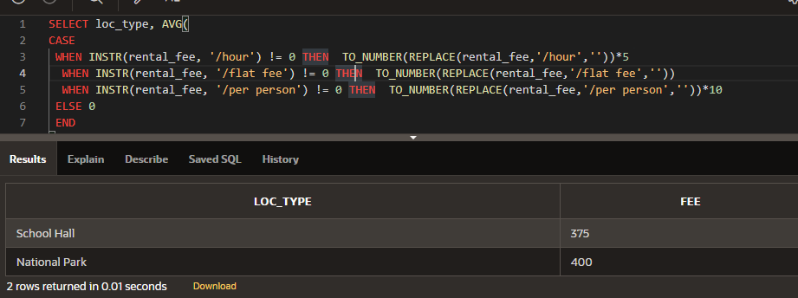

1. Rewrite the following query to accomplish the same result: SELECT DISTINCT MAX(song_id)

FROM d_track_listings WHERE track IN ( 1, 2, 3);

SELECT track, MAX(song_id)

FROM d_track_listings

WHERE track IN ( 1, 2, 3)

GROUP BY track;

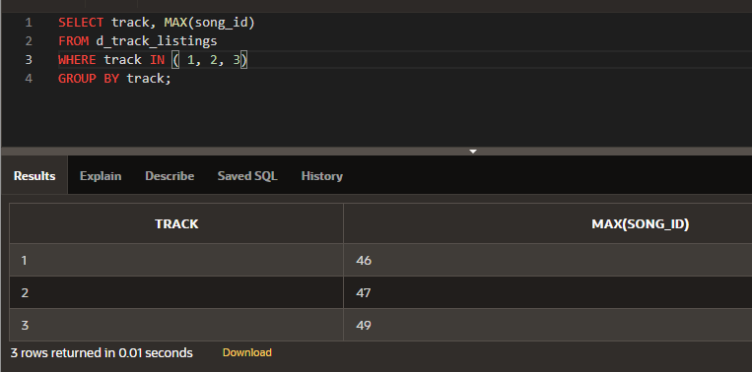

1. Indicate True or False

a. If you include a group function and any other individual columns in a SELECT clause, then each individual column must also appear in the GROUP BY clause. ПРАВДА

b. You can use a column alias in the GROUP BY clause. ЛОЖЬ

c. The GROUP BY clause always includes a group function. ЛОЖЬ

1. Write a query that will return both the maximum and minimum average salary grouped by department from the employees table.

SELECT ROUND(MAX(AVG(salary)),2) as "Maximum Average of Departments", ROUND(MIN(AVG(salary)),2) "Minimum Average of Departments"

FROM employees

GROUP BY department_id;

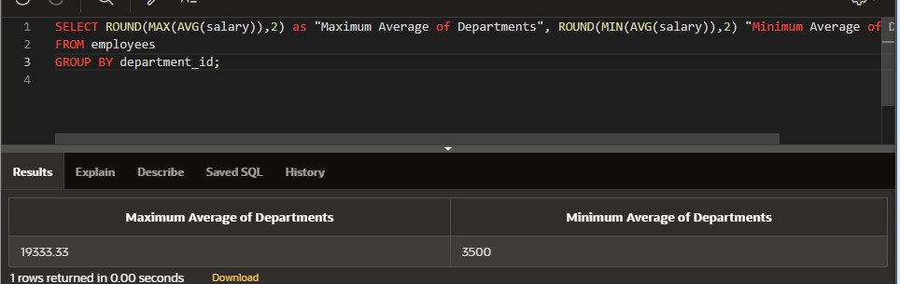

1. Write a query that will return the average of the maximum salaries in each department for the employees table.

SELECT AVG(MAX(salary))

FROM employees

GROUP BY department_id;

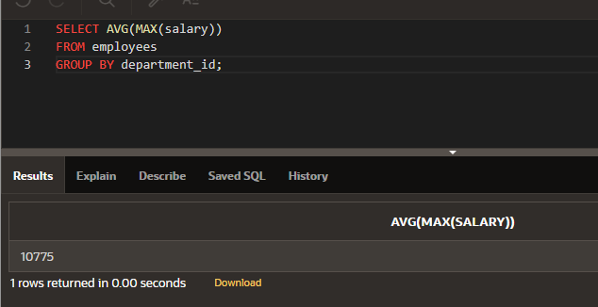

Copyright © 2020, Oracle and/or its affiliates. All rights reserved. Oracle and Java are registered trademarks of Oracle and/or its affiliates. Other names may be trademarks of their respective owners.